Jenkins master slave architecture

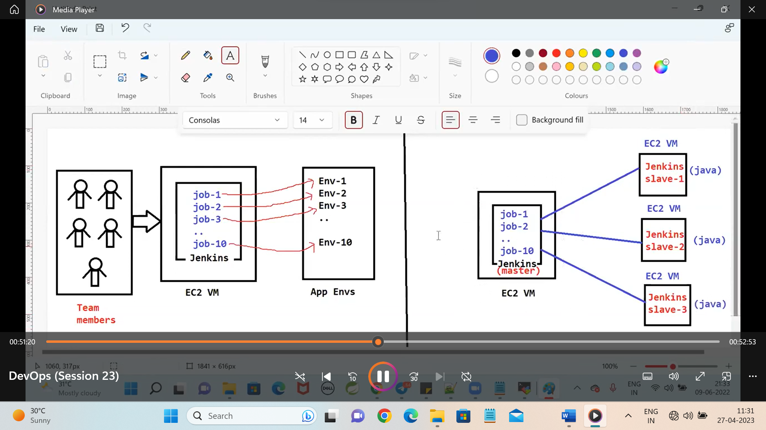

Jenkins is only installed in the master node and java is installed in te slaves to run the jobs only jobs should run in the slaves and all the creation of jobs all should be done in the master only

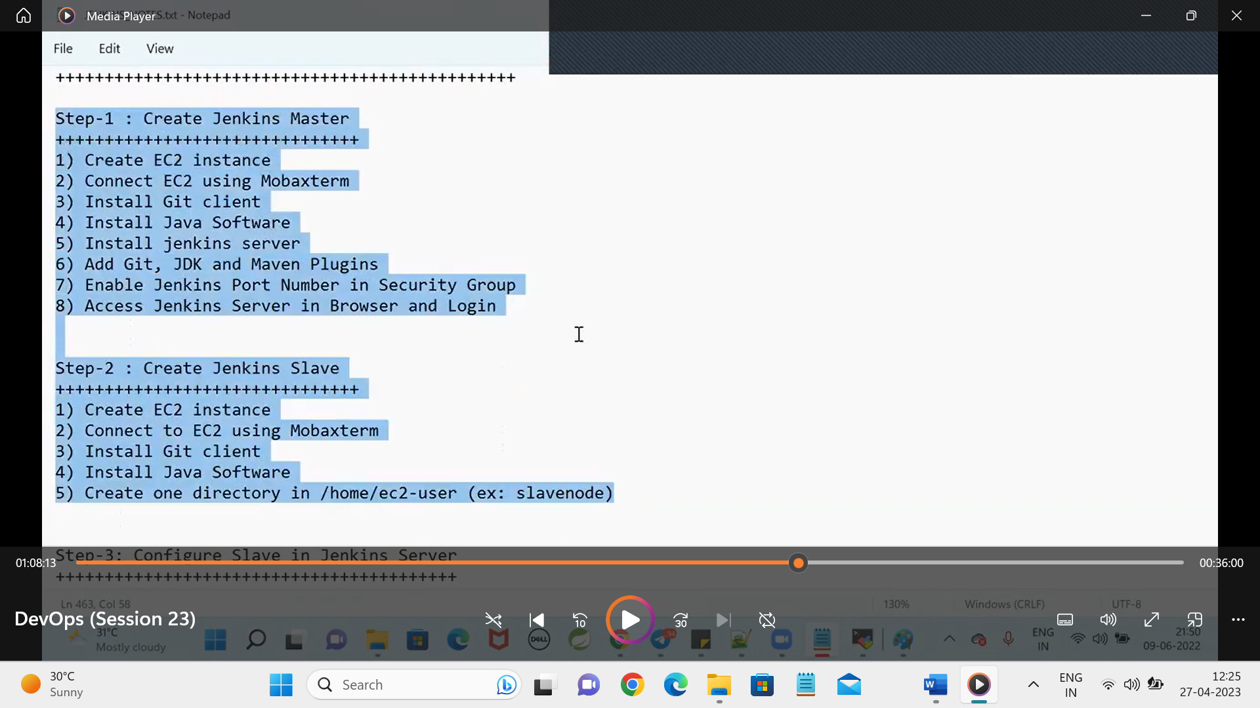

Configure the master and slave by the following steps:

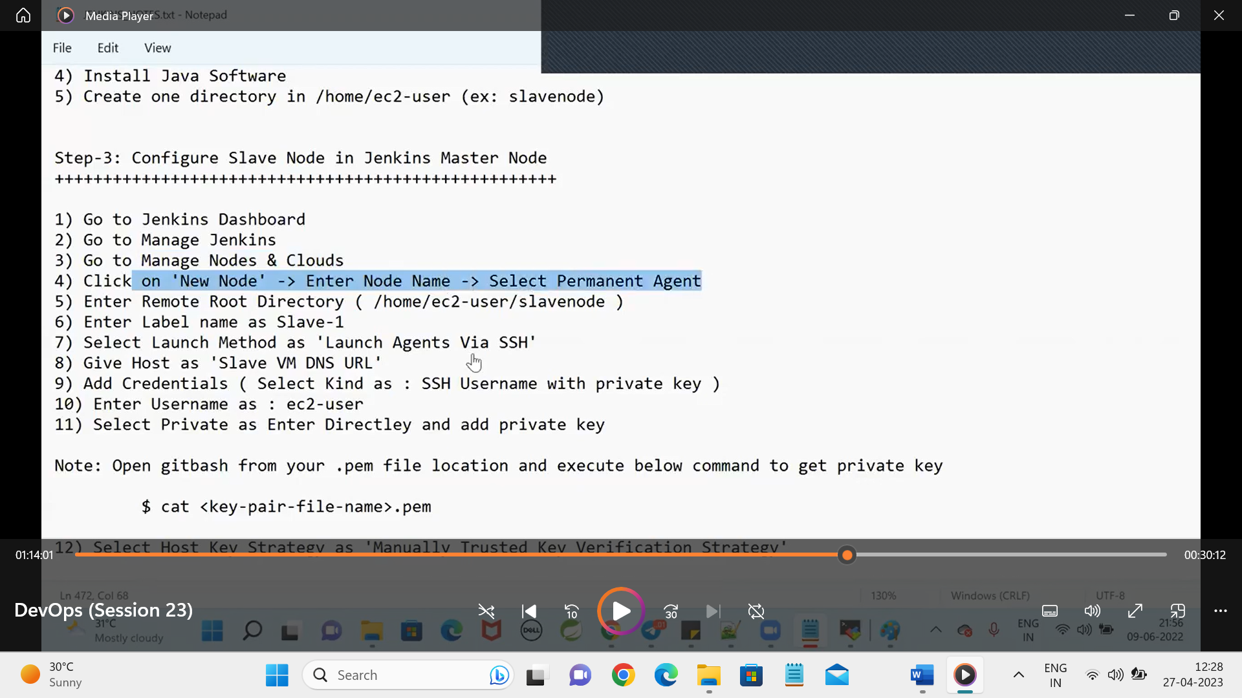

Final step:

